Memo

|  |  |
| --- | --- |
| To: | Troy Scevers |
| From: | Nathan Wiley |
| Date: | October 21, 2022 |
| Re: | Memo 3 |
|  |  |

This week I had a family emergency, so I wasn’t able to work during the week. However, last weekend, I was able to get the pieces that I had designed cut out of the plywood. Unfortunately, my dog damaged my tube rings because we had to leave in a hurry, and I didn’t have time to move them to a secure location. I will need to either fill in the damaged areas or recut these pieces completely.

I ordered parts for the assembly of the base and tube rings:

|  |  |  |  |
| --- | --- | --- | --- |
| Part: | Price | Link: | ETA: |
| Bubble Levels | $4.99 | [www.amazon.com/dp/B098CWYPZC](http://www.amazon.com/dp/B098CWYPZC) | 10/22/2022 |
| Leveling Feet | $19.99 | [www.amazon.com/dp/B08CF2BLTP](http://www.amazon.com/dp/B08CF2BLTP) | 10/22/2022 |
| Latch Clamps | $14.99 | [www.amazon.com/dp/B088ZQ9XMC](http://www.amazon.com/dp/B088ZQ9XMC) | 10/22/2022 |
| Lazy Susan Hardware | $21.79 | [www.amazon.com/dp/B071ZD31Z5](http://www.amazon.com/dp/B071ZD31Z5) | 10/22/2022 |

I have been researching stepper motors more, and I believe I have found the part I wish to purchase. It is a NEMA 17 stepper motor with an encoder and a built in 100:1 planetary gear.

Requirement 1b states that it “Shall be accurate enough to point the telescope within 3600 arcseconds (1 degree) of the desired angle.”. The base motor has 200 steps per revolution and is geared at 100:1 on top of that, so it has the equivalent of 20,000 steps per revolution.

There are 1,296,000 arcseconds in 360 degrees, or 1 revolution, so this motor should provide an accuracy of: (1,296,000 arcseconds per revolution) / (20,000 steps per revolution) = 64.8 arc seconds per step or (0.018 degrees per step). Which is substantially better than the listed requirement. I may still want to gear this down with a 2:1 or 4:1 ratio belt or a gear to provide reduced noise on long exposures.

The minimum required speed to track through the sky is 360 degrees / 24 hours = 15 degrees / 1 hour = 1 degree / 4 minutes = ¼ degree per minute. If the stepper motor has a resolution of 0.018 per step, then the stepper motor must run at a rate of at least 14 steps per minute:

¼ degrees per minute / 0.018 degrees per step = 13.89 steps per minute which is very feasible for any processer to achieve.

Since I was only able to work last weekend, I only put in 5 hours of work this week.

Next week I want to catch up on and finish the base assembly, painting wooden pieces, finish decision matrices for motors, order motors, and hopefully find a processor / board to work with.

**Below is the detailed schedule for this term with completed items in green:**



**Below are pictures of the undamaged pieces:**

|  |  |  |
| --- | --- | --- |
| New Triangle Base | Rocker Box Side | Turntable base |
|  |  |  |

**Below is a picture of the rough assembly of the base:**

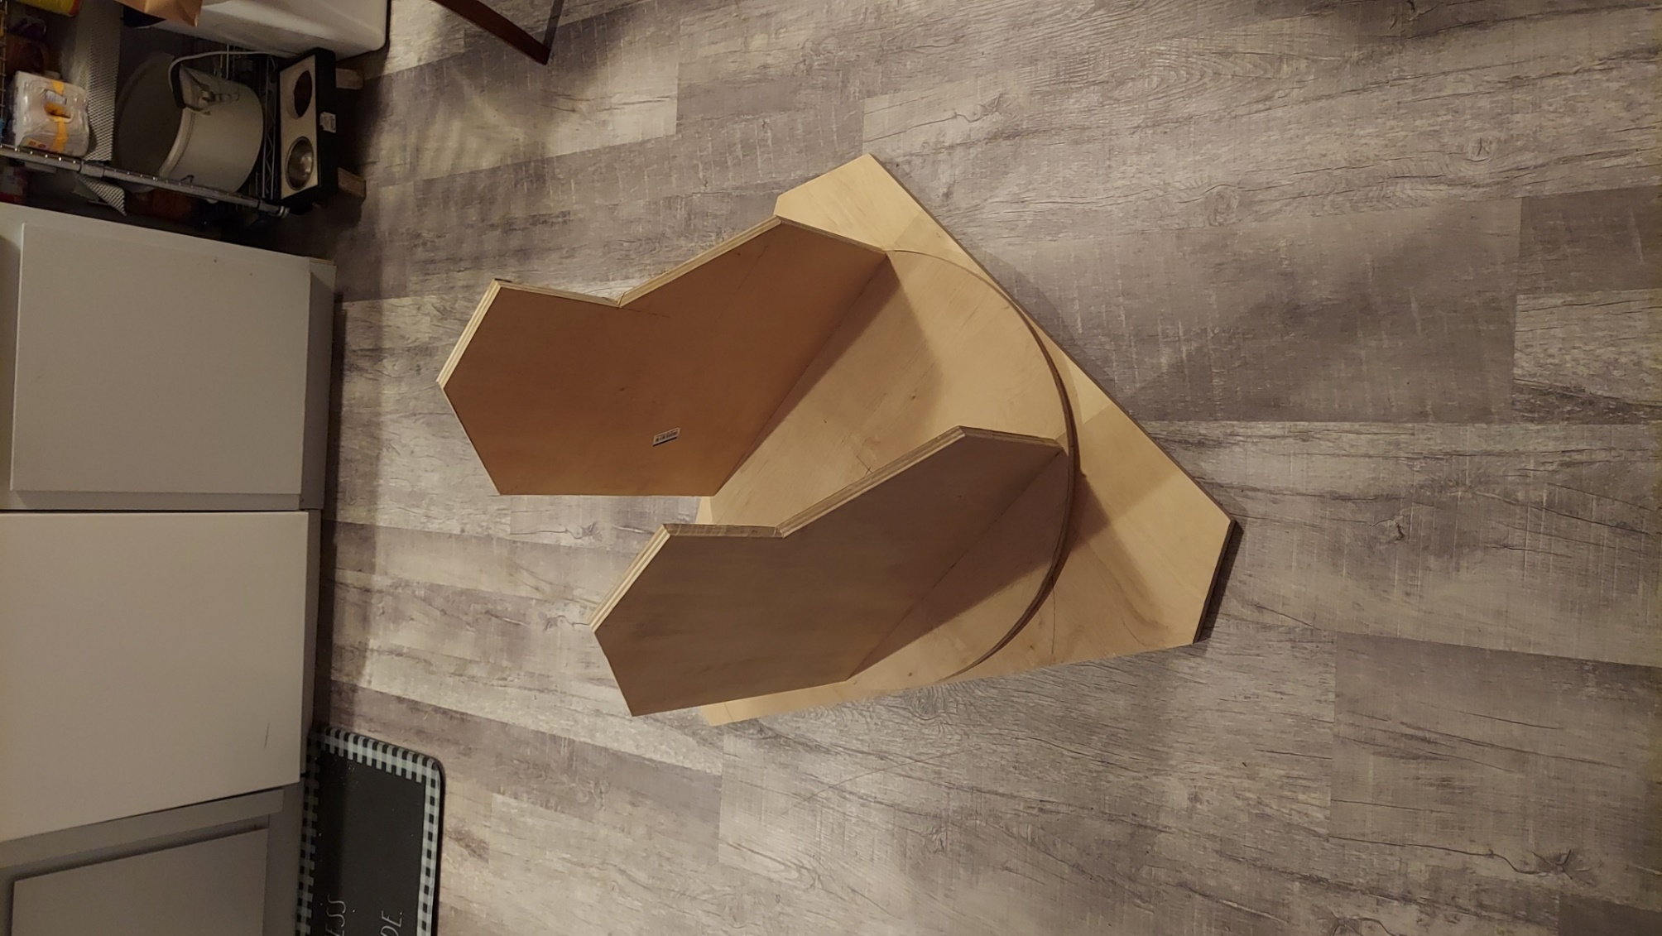

**Below are pictures of the damaged tube ring pieces**

